Chapter 1

First-Order Ordinary Differential Equations

1 Introduction
1.1 Applications of Ordinary Differential Equations - A Simple Example
Physical Problem
⇒ Math Modeling
⇒ Solving the Math Problem
- Interpretation of Its Physical Meaning

F = ma = mg where a = g = acceleration of gravity
= v(t) or, for Δt → 0, = v
Since a = =
we have = a = g ≈ constant

The above equation can be written as
= g
= g t + c₁ or v = g t + c₁
and h = g t² + c₁ t + c₂
I.C. (Initial Condition):
h(0) = 0 ⇒ c₂ = 0
v(0) = 0 ⇒ c₁ = 0

Thus, we have h = g t² #
where h = falling distance
g = acceleration of gravity
t = time

A Physical Problem
⇒ Mathematical Model
⇒
⇒ Interpretation in Terms of Its Physical Meaning

1.2 Definitions

(1) Ordinary Differential Equation
y = y(x)
y: dependent variable; x: independent variable
f(y, x, y', y", ... ) = 0
where y' = , y" =
Partial Differential Equation

(2) Order (階) : the highest derivative of y with respect to x in the equation
y" + 4y' + 5y = 0 2nd order
y' − y cosx = 0 1st order
(y⁽⁴⁾)^{3/5} − 2y" = cosx 4th order

The first order ODEs can be written as

(3) Solution: A solution of an n^{th}–order differential equation is a function that is n times differentiable and that satisfies the differential equation.
A solution of a given 1st-order differential equation on some open interval is a function that has a derivative and satisfies this equation for all x in that interval; that is, the equation becomes an identity if we replace the unknown function y by h and y’ by h’.

(a) General solution: contains arbitrary constants, e.g.,
= g
⇒ h(t) = g t² + c₁ t + c₂
where c₁ and c₂ are constants and are arbitrary.
(b) Particular solution: no arbitrary constants
= g with = 0, h(t=0) = 0 (initial conditions)
⇒ h(t) = g t²
(c) Trivial solution: If y = 0 is a solution to a differential equation on an interval I, then y = 0 is called the trivial solution to that differential equation on I. e.g.,
= 3y
y = 0 −− trivial solution
y = c e^{3x} −− general solution
(d) Explicit solution: y = f(x)
e.g., y = c e^{3x} is an explicit solution of y' = 3y
(e) Implicit solution: f(x, y) = 0
e.g., x² + y² − 1 = 0 is an implicit solution of y y' = – x.
(f) Singular solution: a solution can't be obtained from the general solution
e.g., y'² − x y' + y = 0
y = c x − c² −− general solution
y = x²/4 −− singular solution

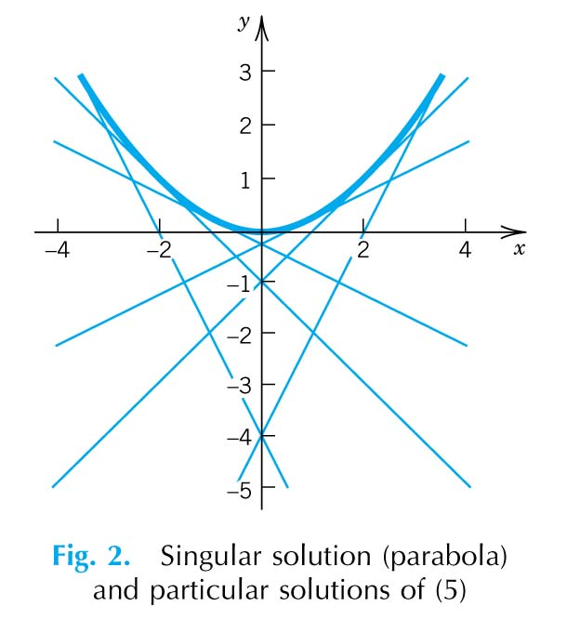

(4) Verification of Solution

[Example] The solution of is. Verify: .

[Example] The solution of on the interval is. Verify: .

- There are equations that do not have solutions at all. For example, does not have a solution for real y.

- There are equations that do not have general solutions. For example, has only a trivial solution.

- Separable Differential Equations

(Textbook Sec. 1.3)

2.1 Separation of Variables (分離變數法)
If the differential equation can be reduced to the form
g(y) y' = f(x)
or, since y' =
g(y) dy = f(x) dx
then we have a separable equation and the general solution can be obtained by integration on both sides:
dy = dx + c
where c is an arbitrary constant.

[Example] = x
[Solution] = x dx
= + c
or sin^{–1}y = + c implicit solution
or y = sin ( + c ) explicit solution

[Example]
[Solution]
Trivial solution!

[Example] y' = – 2 x y
[Solution] = − 2 x y
= − 2x dx
ln |y| = – x² + c
or |y| = exp{ -x² + c }
or y = c' e^{–x2}
Note that if c' = 0, we have a trivial solution y = 0.

[Example]
[Solution]

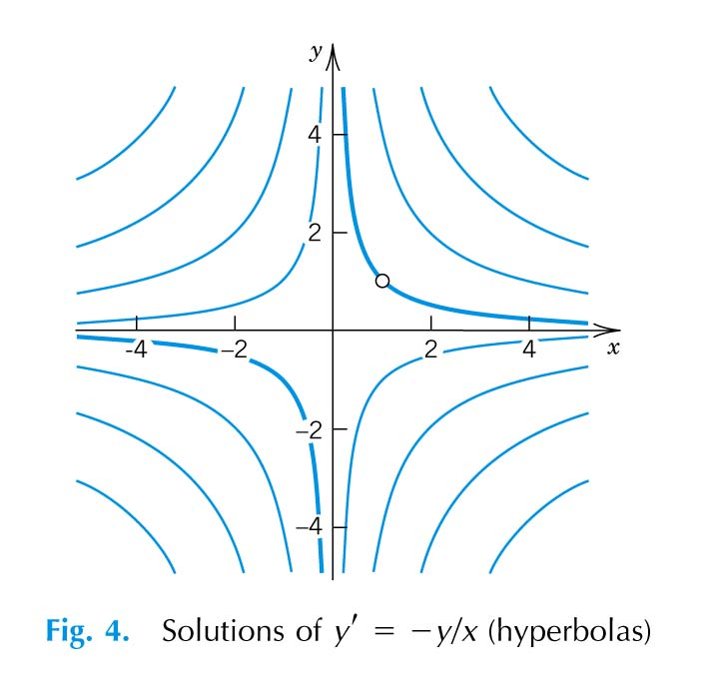

[Exercises] Please solve the following equations
(i) e^{x-y} + 1 = 0
(ii) y’ = 2 x y ; y(0) = 1
(iii) y' =

An analytic function f(x,y) in a domain D of the xy-plane can be factored in D, f(x,y)=g(x)h(y), if and only if in D,

2.2 Initial Value Problems

Ordinary Differential Equation + Initial Condition(s)

[Example] ( x² +1 ) y' + ( y² +1 ) = 0 y(0) = 1
[Solution] = −
tan^{–1}y = – tan^{–1}x + c
or tan^{–1}x + tan^{–1}y = c
tan(tan^{–1}x + tan^{–1}y) = tan c
or = tan c = c' −− general solution
Since y(0) = 1, we have tan c = 1
⇒ = 1
or y = # −− particular solution
Note that in general there is no arbitrary constant for initial value problems.
3 Equations Reducible to Separable Forms

(1) y' = f(ax + by + c) where a, b and c are constants
Let u = ax + by + c
= a + b = a + b f(u)
⇒ = + c
[Example] y' = (x + y)²+ a² a = constant
Let u = x + y
= 1 +
⇒ = 1+u² + a²
∴ = dx
and = x + c
tan^{–1} = x + c
u = tan( x+ c')
where
∴ y = tan( x+ c') − x #

(2) y' = f(y/x)
Let y/x = u or y = x u
= x + u = f(u)
=
= ln |x| + c
or x = c₁ exp
[Example] y' = where k = constant
Let y/x = u or y = x u
∴ y' = u + x u'
u + x u' = ; or x u' = -
⇒ du + = 0
∴ tan^{–1} u + ln + ln |x| = c
or tan^{–1} + ln = c #

[Exercises] Please solve the following equations:
(i) y' =
(ii) y' =
(iii) y' =
(3) y' = f where A, B, C, a, b, c, are constants
a. C = c = 0
y' = f = f = g(y/x)
⇒ Same as Case (2)
b. C ≠ 0 and/or c ≠ 0
(i) A b − B a ≠ 0
Let x = t + h
y = z + d
where h and d are constants to be determined later
We may take appropriate h and d such that

then, the differential equation reduces to
= f
⇒ Same as Case (3)a or Case (2)
(ii) A b − B a = 0 or
(a) a = b = 0
y' = f = F (px + qy+r)
⇒ Same as Case (1)
(b) Set A x + B y + C = u or a x + b y + c = u
⇒ Same as Case (1)

- Exact Differential ⇒ Read Section 5 .

[Example] (7y − 3x + 3) y' + 3y − 7x + 7 = 0
[Solution] The above ODE can be written as
y' =
Check A b − B a = 7×7 − (−3) × (−3) ≠ 0
Let x = t + h
and y = z + d
and take h and d such that

or
∴ d = 0 h = 1
and t = x − 1 z = y
∴ = = =
thus = ⇒ Case (2)
Ans: ( y + x − 1 )⁵ ( y − x + 1 )² = C Please check it !! #

[Example] (y − x + 5 ) y' = y − x + 1
[Solution] A b − B a =0
Let u = y − x + 1
= – 1 = y' −1
∴ y' = 1 + u'
⇒ (u + 4) (1 + u') = u
or ( u + 4 ) u' = –4
du = dx + c
∴ u² + 4u + 4x = c
i.e., (y − x)²+ 10 y − 2 x = c'
[Exercise] Solve y' =

- Modeling (Textbook Sec. 1.4)

[Example] Time required for draining a tank −− Torricelli's Law

ΔV = A v Δt
where ΔV = volume of water flows out during Δt
A = cross-sectional area of the outlet = 0.7854 cm²
v = velocity of the out-flowing water
Torricelli's law states that
v = 0.6
where g = acceleration of gravity = 980 cm/sec²
h = height of water above the outlet

Note that ΔV must equal to change of the volumes of water in the tank, i.e.,
ΔV = − B Δh (Mass Balance)
where B = cross-sectional area of the tank = 7854 cm²
Δh = decrease of the height h(y) of the water
i.e., A v Δt = – B Δh
or = − = −
Letting Δt → 0, we obtain the differential equation
= − = − 0.00266
Initially, the height of the water is 150 cm, i.e.,
h(0) = 150 cm −− Initial Condition
we then have
h(t) = (12.25 − 0.00133 t)² #

[Exercises] Please do the exercises on p. 18, 19 of the Textbook.
5 Exact Differential Equations (Textbook Sec. 1.5)
5.1 Total Differential (Exact Differential)
The total differential du of a function of two variables u(x,y) is defined by
du = dx + dy
e.g., if u(x,y) = x y, then the total differential of u is
du = y dx + x dy
Suppose that we take the total differential of the equation u(x,y) = c, then
du = dx + dy = 0
e.g., the total differential of the equation
x y = c
is y dx + x dy = 0
or y' = – y/x (ODE!)
Reversing the situation, suppose that we start with the differential equation
M(x,y) dx + N(x,y) dy = 0
If we can find a function u(x,y) such that
= M(x,y) = N(x,y)
then the differential equation becomes
dx + dy = 0
which has the general solution
u(x,y) = c
In this case, the differential equation
M(x,y) dx + N(x,y) dy = 0
is called an exact differential equation.

5.2 Condition for Exact Differential
If M(x,y) dx + N(x,y) dy = 0 is an exact differential equation, then
M(x,y) = ; N(x,y) =
But = = =
Thus,
is the necessary and sufficient condition for Mdx + Ndy to be a total differential.

5.3 Solution for Exact Differential Equations

Since = M(x,y)
the solution has the following form
u = + k(y) = c
To determine k(y), we take of the above equation and compare the result with
= N(x,y)
Alternatively,

[Example] Solve x y' + y + 4 = 0
[Solution] (y + 4) dx + x dy = 0
or M = y + 4 ; N = x
Check the exactness by
= 1 = ⇒ Exact Differential
Solve for u = + k(y)
u = + k(y) = x y + 4x + k(y)
But = N(x,y)
or x + k'(y) = x
we have k'(y) = 0 or k(y) = c*
Thus, we have the solution u = c or
x y + 4x + c* = c
or x y + 4x = c' #
Differentiate with respect to x, i.e.

[Example] (1 − sin x tan y) dx + (cos x sec² y) dy = 0
[Solution] M = 1 − sin x tan y
N = cos x sec² y
= − sin x sec² y = ⇒ Exact Differential
The solution is
u = + k(y)
= + k(y)
= x + cos x tan y + k(y)
= N(x,y)
or cos x sec² y + k(y)' = cos x sec² y
∴ k'(y) = 0 or k(y) = c*
The solution u = c becomes
x + cos x tan y = c' #

6 Integrating Factors (Textbook Sec. 1.5)
dx + 2 x dy = 0 −− not exact
Since
Multiply both sides of the above equation by F(x,y) = y/x (integrating factor), then
+ 2 y dy = 0 −− Exact Differential
since
A differential equation which is not exact can be made exact by multiply it by a suitable function F(x,y) ( ≠ 0). This function is then called an integrating factor.
P(x,y) dx + Q(x,y) dy = 0 −− not exact
F(x,y) P(x,y) dx + F(x,y) Q(x,y) dy = 0 −− Exact
In this case, we need
=
which is a partial differential equation of F(x,y). In general, it is difficult to determine an integrating factor from the above equation. However, in some special cases, the integrating factor can be found as shown in the following special cases (Read the textbook, p. 28, for details):

(i) If = f(x), i.e., a function of x only, then F(x)=e∫ ^{f(x)dx} is an integrating factor, which is also a function of x only.
[Proof]
Since the integrating factor satisfies the PDE
=
or F + P = F + Q
or F = Q − P
If we assume that the integrating factor F is function of x only, i.e.,
F = F(x) ⇒ = 0
i.e., F = Q
or = =f(x) (by assumption)
The above equation can be solved if the right-hand-side is function of x only, i.e.,
= f(x) only
and the solution is then the integrating factor
F = e∫ ^{f(x)dx}

(ii) If = f(y), i.e., a function of y only, then e– ∫ ^{f(y)dy} is an integrating factor, which is also a function of y only.
[Proof]: Exercise!

(iii) If = f(x+y) = f(v), then e∫ ^{f(v)dv} is an integrating factor, which is a function of x+y.

(iv) If = f(xy) = f(v), then e∫ ^{f(v)dv} is an integrating factor, which is a function of xy.

[Example] (4 x + 3 y²) dx + 2 x y dy = 0
P = 4 x + 3 y² Q = 2 x y
= 6 y ≠ 2 y = −− not exact
Check = = = f(x)
Thus, the integrating factor F(x) is
F(x) = e∫ f(x)dx = e= x²
Multiply F(x) on both sides of the differential equation, we have
(4 x³ + 3 x² y²) dx + 2 x³ y dy = 0 −− Exact
⇒ x⁴+ x³ y² = c #

[Example] 2 cosh x cos y dx − sinh x sin y dy = 0
Note that cosh x ≡
sinh x ≡
and d cosh x/dx = sinh x
d sinh x/dx = cosh x
P = 2 cosh x cos y
Q = – sinh x sin y
=− 2 cosh x sin y ≠ − cosh x sin y =
Check =
= = f(x)
Thus, the integrating factor F(x) is
F(x) = e∫ ^{f(x)dx} = e = sinh x
Multiply sinh x on both sides of the differential equation, we have
2 sinh x cosh x cos y dx − sinh² x sin y dy = 0
which can be solved by
and = F Q ⇒ − sinh²x sin y + k'(y) = - sinh² x sin y
⇒ k(y) = constant
Thus the solution to the above ODE is
sinh²x cos y = c #

[Exercise] x y dx + ( x² + y² + 1 ) dy = 0

[Exercise] ( y² + x y + 1 ) dx + ( x² + x y + 1 ) dy = 0

[Question] Is the integrating factor of a given ODE unique?
7 Linear Differential Equations (Textbook Sec. 1.6)

  - Definitions

Linear Differential Equations
An n^{th}–order differential equation is linear if it can be written in the form
+ a_{n−1}(x) + ... + a₁(x) + a_{o}(x) y = f(x)
Hence, a first-order linear equation has the form
+ p(x) y = r(x)
e.g., y' − y = e^{2x} 1st– order linear
y' − = − x²y³ 1st–order nonlinear
y'' + a(x) y' + b(x) y = f(x) 2nd–order linear

Homogeneous Differential Equations
If the function f(x) = 0 [or r(x) = 0], then the above linear differential equation is said to be homogeneous; otherwise, it is said to be nonhomogeneous.
e.g. y' − y = 0 homogeneous
y' − y = e^{2x} nonhomogeneous

  - Solution of the First-Order Linear Differential Equations

Homogeneous Equation
The solution of the linear homogeneous equation
y' + p(x) y = 0
can be obtained by separation of variables
= − p(x) dx
or y(x) = c e

Nonhomogeneous Equations
The nonhomogeneous equation
y' + p(x) y = r(x)
can be written in the following form
[p(x) y − r(x)] dx + dy = 0
which is of the form
P(x) dx + Q(x) dy = 0
with P(x) = p(x) y − r(x)
Q(x) = 1
Since = p(x) ≠ 0 =
the above equation is not exact differential. However,
= p(x)
we have the integrating factor
for the differential equation. Multiply the differential equation by the integrating factor, we have
[y' + p(x) y] e= r(x) e
According to chain rule, the left side of the above equation is the derivative of ye, we have
= r(x) e
Integrating both sides of the above equation with respect to x, we have
y e= + c
or y = e⁻
Alternative Solution Procedure：
i. Rearrange the equation in the standard form: y' + p(x) y = r(x)
ii. Derive the integrating factor e
iii. Multiply both sides of the given equation by this factor
iv. Integrate both sides of the resulting equation. Note that the integral of the left is always just y times the integrating factor.
v. Solve the integrated equation for y.

[Example] y' = y + x² , y(0) = 1
y' − y = x² ⇒ y' + p(x) y = r(x)
thus, the integrating factor is
e= e= e^{– x}
Multiply both sides of the differential equation according to the alternative procedure, we have
e^{– x} (y' − y) = x² e^{– x}
or ( y e^{– x})' = x² e^{– x}
Integrating both sides, we have
y e^{–x} = + c = c − ( x² + 2 x + 2 ) e^{–x}
Thus, y = c e^{x} − (x² + 2 x + 2) −− general solution
Since y(0) = 1 ⇒ c = 3
thus y = 3 e^{x} − ( x² + 2 x + 2 ) −− particular solution for y(0) = 1
The general solution can also be obtained by the general formula
y = e⁻
= e^{x}
= c e^{x} − (x² + 2x + 2) #

[Example] = x³ − 2 x y y(1) = 1
[Solution] y' + 2 xy = x³ ⇔ y' + p(x) y = r(x)
∴ The integrating factor is
e= e= e
Multiply both sides by e and integrating, we have
e ( y' + 2 x y ) = x³ e
or ( e y)' = x³ e
e y = + c
or y = e
(integration by parts)
∴ y = + c e
Since y(1) = 1, we have c = e
thus, y = + e #

Bernoulli's Equations (Sec. 1.6, p. 36 of the Textbook)
The equation
+ p(x) y = g(x) yª ( a is any real number )
which is known as the Bernoulli's Equation, can be reduced to linear form by a suitable change of the dependent variables. For a = 0 and a = 1, the equation is linear, and otherwise, it is nonlinear. Set
u(x) = y^{1-a}
then u' (x) = ( 1 − a ) y^{–a} y'
so if we multiply both sides of the differential equation by (1−a) y^{–a}, we obtain
(1−a) y^{–a} y' + (1−a) p(x) y^{1-a} = (1−a) g(x)
or u' + (1−a) p(x) u = (1−a) g(x)
The equation is now linear and may be solved as before.

[Example] y' − = − x²y³
[Solution] Compare the above equation with y' + p(x) y = g(x) yª
we have a = 3
Set u(x) = y^{1-a} = y^{–2}
⇒ u'(x) = – 2 y^{–3} y'
Multiply both sides of the equation by − 2 y^{–3}, we obtain
− 2 y^{–3} y' + 2 y^{–2} = 5 x²
or u' + u = 5 x² −− 1st–order linear differential equation.
The integrating factor is then
e= x²
multiply both sides of the differential equation of u by x², we have
x² u' + 2 x u = 5 x⁴
or (x² u)' = 5 x⁴
⇒ x² u = x⁵ + c
or x² y^{–2} = x⁵ + c
⇒ y = ± ( x³ + c x^{–2} ) ^{–1/2} #

[Exercise] Show that the differential equation
y' + p(x) y = f(x) y ln y
can be made linear if we set u = ln y
Read p. 40, Problems 44-47 for Riccati and Clairaut Equations.

Riccati’s Equation

- Except in special instances, the solution cannot be given in closed form
- If one particular solution is known, then the remaining solutions can be explicitly derived.

Consider two distinct solutions
Let

[Exercise]
Thus,

8 Applications of First-Order Differential Equations - Modeling

[Example 1]
A tank is initially filled with 100 gal of salt solution containing 0.5 lb of salt per gallon. Fresh brine containing 3 lb of salt per gallon runs into the tank at the rate of 2 gal/min, and the mixture, assumed to be kept uniform by stirring, runs out at the same rate. Find the amount of salt in the tank at any time t.
Let Q lb be the total amount of salt in solution in the tank at any time t, and let dQ be the increase in this amount during the infinitesimal interval of time dt. At any time t, the amount of salt per gallon of solution is therefore Q/100 (lb/gal). The material balance of salt in the tank is
= –
The rate at which salt enters the tank is
2 gal/min × 3 lb/gal = 6 lb/min
Likewise, since the concentration of slat in the mixture as it leaves the tank is the same, as the concentration Q/100 in the tank itself, the rate of salt leaves the tank is
2 gal/min × lb/gal = lb/min
Hence, the rate of accumulation of salt in the tank dQ/dt is
= 6 −

This equation can be written in the form
=
and solved as a separable equation, or it can be written
+ = 6
and treated as a linear equation.
Considering it as a linear equation, we must first compute the integrating factor e= e= e^{t/50}
Multiplying the differential equation by this factor gives
e^{t/50} = 6 e^{t/50}
From this, by integration, we obtain
Q e^{t/50} = 300 e^{t/50} + c
or Q = 300 + c e^{–t/50}
Substituting the initial conditions t = 0, Q = 50, we find c = − 250
Hence, Q = 300 − 250 e^{–t/50} #

[Example 2]
A tank is initially filled with 100 gal of salt solution containing 0.5 lb of salt per gallon. Fresh brine containing 1 lb of salt per gallon runs into the tank at the rate of 3 gal/min, and the mixture, assumed to be kept uniform by stirring, runs out at the 2 gal/min. Find the amount of salt in the tank at any time t.
In this case, the rate at which salt enters the tank is
3 gal/min × 1 lb/gal = 3 lb/min
Since the amount of brine in the tank increases with time (at 1 gal/min), the concentration of salt in the tank is then
lb/gal
Therefore, the rate of salt leaves the tank is
2 gal/min × lb/gal = lb/min
From the mass balance of salt of the system, we have
= 3 −
or + = 3
The integrating factor in this case is
e= e= (100 + t )²
So that, we have
[ ( 100 + t )² Q ]' = 3 ( 100 + t )²
or Q(t) = ( 100 + t ) + c ( 100 + t )^{–2}
Setting t = 0, we find that c = – 50(100)², so that
Q(t) = 100 + t − 50 #
9 Approximate Solutions

9.1 Method of Direction Fields −− Graphic Method
(Textbook Sec. 1.2 & 1.8)

Slope of a Curve
y' = f(x,y) ⇒ y = g(x ; c)
or F(x,y,c) = 0

[Example] y' = –1 ⇒ y = –x + c or x + y = c

[Example] y' = ⇒ y = c x²

Orthogonal Trajectories
The curves of a family C is said to be orthogonal trajectories of the curves of a family K, and vice versa, if at every intersection of a curve of C with a curve of K, the two curves are perpendicular.

[Example] y' = –1 ⇒ y = –x + C or x + y = C
y' = 1 ⇒ y = x + K or y − x = K
The two families of curves, x + y = C & y − x = K, are orthogonal trajectories of each other.

[Example] y' =
⇒ y = C x² ( the Solid Lines in the following Figure )
Orthogonal trajectories: (the Dashed Lines in the above Figure)
y' = – = − ⇒ + y² = K

Method of Direction Fields for y' = f(x,y)

Step 1 Plot the isoclines (curves of constant slope) of y' = f(x,y), i.e., plot the curves for
f(x,y) = k = constant
Step 2 Draw a number of parallel short line segments (lineal elements) with slope k along each isocline f(x,y) = k
Step 3 Connect the lineal elements to get the approximate solution curves.

[Example] y' = x y
or = x dx
⇒ ln y = x² + c
or y = c' e

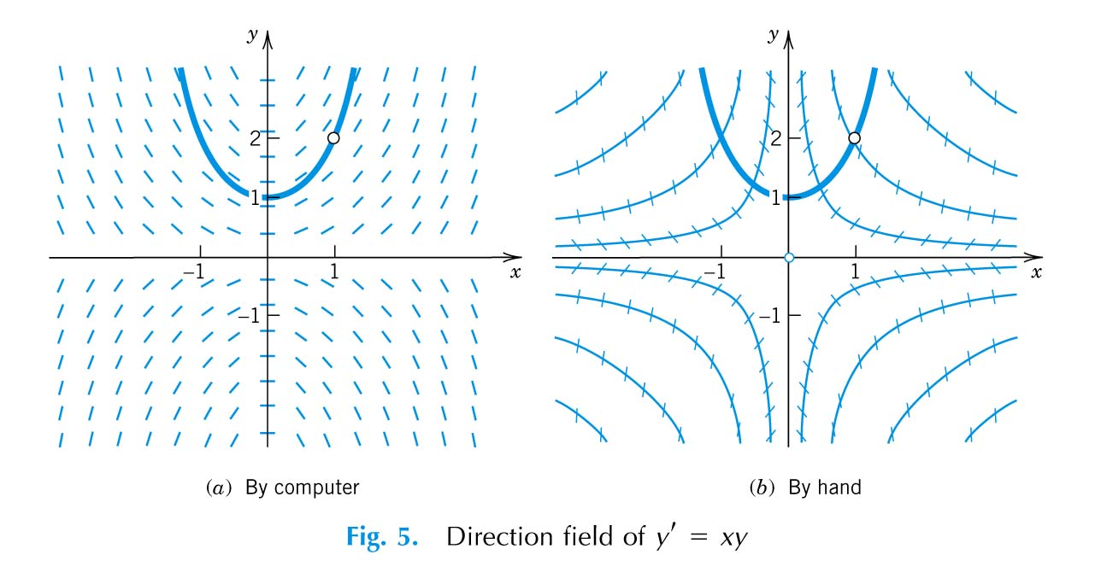

  - Picard's Iteration Method −− Successive Approximations
(Textbook p. 56-58)

Iteration Method :

Assume we need to solve the (positive) value of x of the algebraic equation:
x² + x = 1
or, alternatively
x =
Since the above equation is nonlinear, we propose to solve the value of x by iteration if we assume that the initial guess of x be 0.5, i.e.,
x_{o} = 0.5
then the 1st approximation of x, x⁽¹⁾, can be calculated by
x⁽¹⁾ = = = 0.707
Similarly, the 2nd approximation of x, x⁽²⁾, is then
x⁽²⁾ = = = 0.541
By the same token, the (n+1)^{th} approximation of x can be solved by
x^{(n+1)} =
where x^{(n)} is the n^{th} approximation of x. We then obtain, successively, that
⇒ ... x⁽⁵⁾ = 0.657 ... x^{(∞)} = 0.618

Similarly, consider the initial value problem
y' = f(x, y) ; y(x₀) = y₀
Integrate both sides of the differential equation from x₀ to x with respect to x yields
=
or y(x) = y(x₀) +
Since the function y(t) in the integrand is not known a priori, the integral of the right-hand-side of the above equation can not evaluated unless the approximations of y(t) are introduced. We now define a sequence of functions {y_{n}(x)}, called Picard iterations, by the successive formulas
y₀(x) = y₀
y₁(x) = y₀ +
y₂(x) = y₀ +
y₃(x) = y₀ +
.
.
y_{n}(x) = y₀ +
Remarks: Picard's method is of great theoretical values in connection with Picard's existence and uniqueness theorem. Its practical value is limited because it involves integrations that may be complicated.

[Example] Consider the initial value problem
y'(x) = y ; y(0) = 1
In this case, f(x,y) = y(x)
y₀(x) = y₀ = 1
y₁(x) = y₀ + = 1 + = 1 + x
y₂(x) =y₀ + = 1 +
= 1 + x +
y₃(x) = y₀ +
= 1 + = 1 + x + +
Finally, we will have
y_{n}(x) = 1 + x + + ... + =
Hence, limy_{n}(x) = lim
which converges to the exact solution e^{x}.
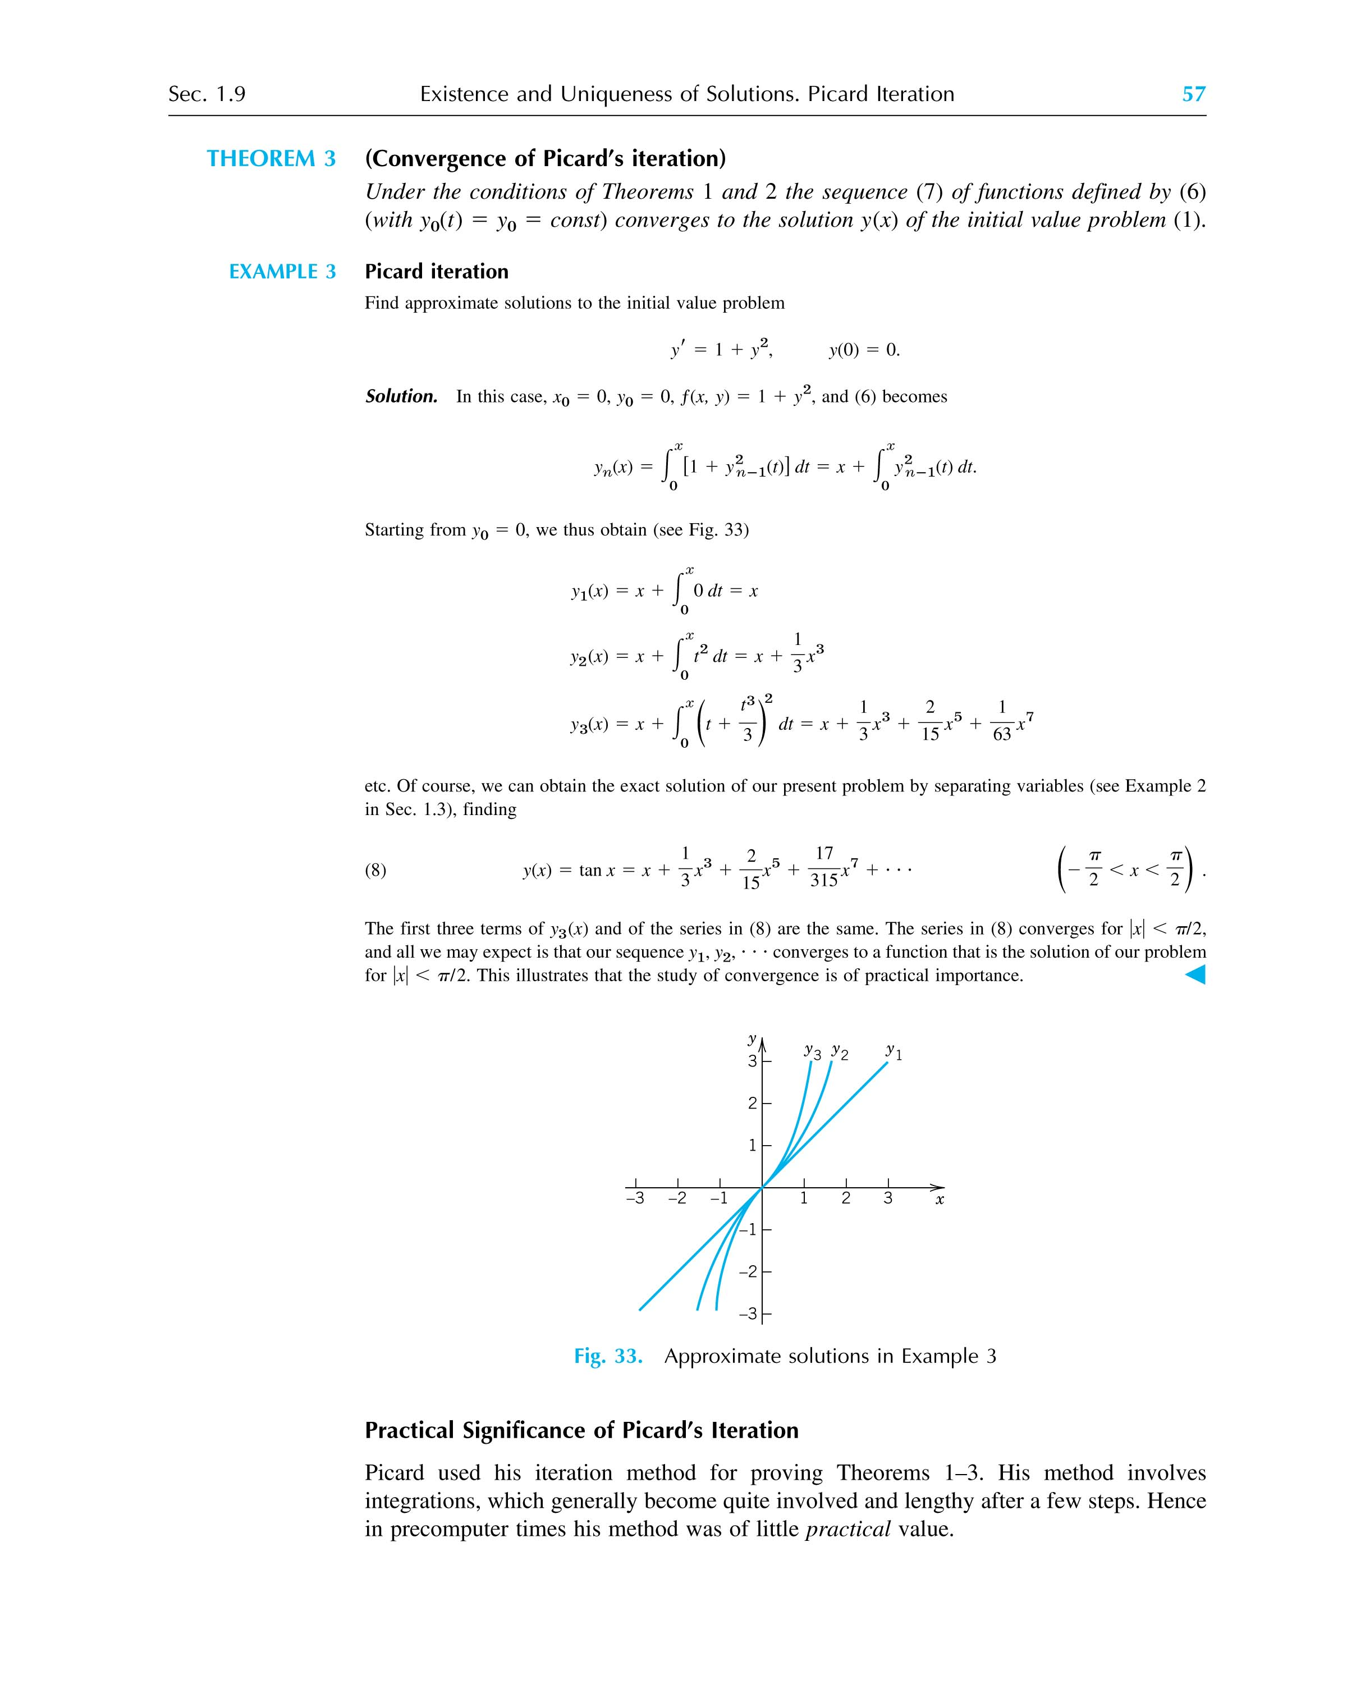
9.4 Numerical Method −− Read. 19.1, 19.2 of the textbook
10 Existence and Uniqueness of Solutions

[Examples]
(i) |y'| + |y| = 0 y(0) = 0 ⇒ Trivial solution, y = 0
y(0) = 1 ⇒ No solution exists
(ii) y' = x y(0) = 1 ⇒ unique solution, y = x²/2 + 1
(iii) x y' = y − 1; y(0) = 1 ⇒ infinitely many soln's, y = 1 + c x

Questions: 1 Is there a solution to the problem?
2 Is the solution unique?

Existence−Uniqueness Theorem: (Read the Textbook for details)
If f and are continuous and bounded in a rectangle R given by a < x < b, c < y < d that contains the point (x₀,y₀) (see the following figure), then, in an interval x₀ – h < x < x₀ + h contained in a < x < b, there is a unique solution y = y(x) of the initial value problem
= f(x,y) ; y(x₀) = y₀
Note that the above theorem is valid for a small region around the initial point, we call such a theorem a local existence−uniqueness theorem.

[Example] Check the initial value problem
= x² + y³ y(0) = 1
Since f(x,y) = x² + y³ and = 3 y² are continuous everywhere, they are continuous in any rectangle R containing the initial point (0,1). Hence, a unique local solution exists.

[Example] Check the initial value problem
= x y^{1/3} y(0) = 0
Since = is not bounded at the initial point (0,0), the above theorem does not apply to this problem. Indeed, the problem has two solutions
y = 0 and y =

[Exercise] Is the solution y = x²/4 to the differential equation y' = with the initial condition y(0) = 0 unique?

11 Review Questions and Problems of Chapter 1

(I) Solve the following Differential Equations:
1. y' + 2 x y = - 6 x
2. y dx - dy = x² y² dx + x dy
3. (x² + y²) y' + (2xy + 1) = 0, y(2) = -2
4. 2 x y' = 10 x³ y⁵ + y
5 y' =
6 ( 4xy + 6y² ) + ( 2x² + 6xy ) y' = 0
7 x²y' - 3xy = - 2y^{5/3}
8 ( 4y³ - x ) = y
9 x y' - 2 y = x e^{x}
10 2 x y y' + ( x - 1 ) y² = x² e^{x}
11 y' = x e - 3 x² y with y(0) = -1
12 ( x² + y² + 1 ) y' + x y = 0
13 ( y + tan ( x + y ) ) y' + y = 0
14 x² y' = y² + 5 x y + 4 x²
15 ( 3 x e^{y} + 2 y ) dx + ( x² e^{y} + x ) dy = 0
16 ( x + y - 2 ) y' + ( x - y ) = 0
17 (1 + x²) dy + x y dx = dx
18 (2x + 3y - 5) y' + (x + 2y - 3) = 0
19 y' =
20 y' = with y(0) =
21 y' =
II. Under what conditions is the following differential equation exact?
(c x²y e^{y} + 2 cos y ) + (x³ e^{y} y + x³ e^{y} + k x sin y ) y' = 0
Solve the exact equation.

III. Apply Picard's iteration method to the following initial value problems.
(i) y' - x y = 1, ; y(0) = 1
(ii) y' = x y ; y(0) = 1

IV Find the orthogonal trajectories of the circles.
x² + ( y - c )² = 1 + c²
Summary
1. Separation of Variables (分離變數法)
g(y) dy = f(x) dx
dy = dx + c
(a) y' = f(ax + by) where a and b are constants
Let u = ax + by
= a + b = a + b f(u)
⇒ = + c
(b) y' = f(y/x)
Let y/x = u or y = x u
(c) y' = f

2. Exact Differential Equations
M(x,y) dx + N(x,y) dy = 0
Check
Find u such that
= M(x,y) = N(x,y)
Then the general solution is
u(x,y) = c
Integrating Factor:
(a) If = f(x), then e∫ ^{f(x)dx} is an integrating factor.
(b) If = f(y), then e– ∫ ^{f(y)dy} is an integrating factor.
(iii) If = f(x+y) = f(v), then e∫ ^{f(v)dv} is an integrating factor.
(iv) If = f(xy) = f(v), then e∫ ^{f(v)dv} is an integrating factor.

3. Linear Differential Equations
+ p(x) y = r(x)
解題步驟：
i. Write the equation in the standard form: y' + p(x) y = r(x)
ii. Compute the integrating factor e
iii. Multiply both sides of the given equation by this factor
iv. Integrate both sides of the resulting equation. Note that the integral of the left is always just y times the integrating factor.
v. Solve the integrated equation for y.

Bernoulli's Equations
+ p(x) y = g(x) yª ( a ≠ 0 or 1 )
Set
u(x) = y^{1-a}
⇒ u' + ( 1 − a ) p(x) u = ( 1 − a ) g(x)

